Lab Waste
Receptacle | What can go in it | How to dispose | For Info
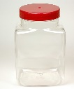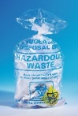  Red Sweetie jar Autoclave bag | ALL Human tissue and sample waste Post December 2019.  - All containers  - Excess tissue  - Blood or blood product tubes | Loosely close* lid of sweetie jar and place in an autoclave bag. Loosely close with autoclave tape.  *To allow steam penetration.  Leave by sink in room. | Once Autoclaved Yellow bag/ yellow tag  Or if blood tubes yellow cinbin/ yellow tag
Autoclave bag | ALL waste contaminated with Genetically Modified Organisms (GMO)  - All TC plastics, stripettes, paper and gloves  - Bacterial cultures and plates.  - Small quantities of tissue remnants from cell isolations. | Loosely close* with autoclave tape.  *To allow steam penetration.  Leave by sink in room. | Once autoclaved yellow bag / yellow tag
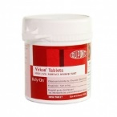  Virkon | ALL liquid waste from Biological and Genetically Modified organisms  - Human liquid waste  - TC media  - Bacterial cultures  - ALL VIRUS WASTE | Add Virkon to generate a 1% w/v solution.  Leave for at least 10minutes.  - Liquid to drains,  - soaked plastics into autoclave bags or biobins | Autoclave waste treated as above
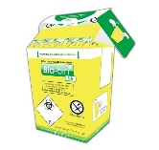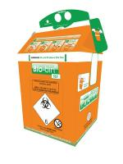  Biobins  Biological non-biological | ALL tips. | Once reached fill line close and put into
 | Yellow: Biologically contaminated | Yellow bag or | Yellow bag/ yellow tag
 | Orange: Non-biologically contaminated | If used for GM (eg TC / bug lab) put into an autoclave bag | Autoclave waste treated as above
 |  | Orange bag. | Orange tag/ orange tag
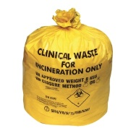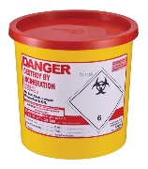  Yellow clinical waste bag or red lidded cin bin  HUMAN waste is to be kept separate. | UNFIXED ANIMAL and HUMAN tissue and fluids,  Cin bin  - blood and fluids  - Contaminated sharps  Bag  - Large human organs/tissue (eg placenta),  - blood/fluid soaked tissue.  - Contaminated plastics/ gloves | Write the date and lab number on bag / cin bin lid.  If contains HUMAN waste, write HUMAN on bag /cin bin lid.  Leave by lab sink for pick up.  If disposing of large human organs, close yellow bag and store at -20. Tell lab support that you have this waste. | Red tag
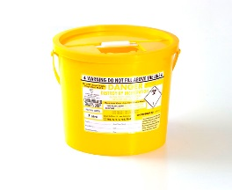  Yellow lidded cin bin | ALL sharps  - Needles (unsheathed),  - glass pipettes,  - glass slides,  - scalpels and microtome blades.  - Small chemically contaminated bottles (not cytotoxic or pharmaceutical)  Paraffin embedded blocks. | Once full, close tab and write the date and the lab number on top  Leave by lab sink for pick up. | Yellow tag
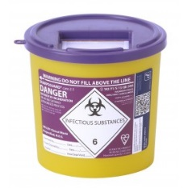  Purple lidded cin bin  KEEP DIFFERENT WASTE TYPES SEPARATE. | Cytotoxic waste  - Phenol contaminated plastics, tips and empty glass stock bottles  - Cyanide contaminated plastics, tips and empty stock bottles | Once full, close tab and write what the waste is, eg “phenol”, the date and the lab number on top.  Leave by lab sink for pick up. | Green tag
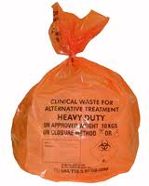  Orange clinical waste bag | All other lab based waste.  - Plastics, tissue remnants,  - GLOVES  - Anything that looks like it has come from a lab. | Once full, close using one of the bag ties (spikes on the inside).  Write the date and the lab number on it.  Leave by lab sink for pick up. | Orange tag
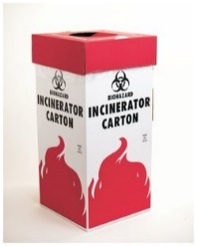  Stripette boxes | Stripettes  ALL stripette, from main lab, in normal bag inside the box. | Close the stripette box and put in a yellow clinical waste bag. Tape bag to top. Write lab number and date on top. Get a new box from wash-up.  Leave by lab sink for pick up | Yellow tag
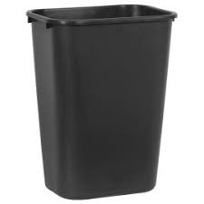  Paper bin | Paper and wrappers  - All outside wrappers and packaging.  - Non-contaminated paper  NO GLOVES nor cardboard | Cleaners pick up
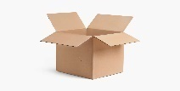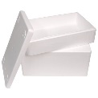 | Leave flattened cardboard and polystyrene boxes by the lab sinks. | Cleaners pick up
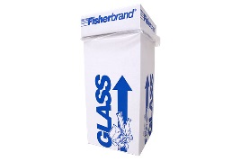  Glass box | “Clean” broken lab glass  Broken lab glassware and clean empty clear bottles. Black out labels. | Close box and write date and lab number on the top.  Leave by lab sink for pick up
Recycling glass | 2.5L Winchester bottles  Clean and deface | leave by the dirty glassware for wash-up to pick up
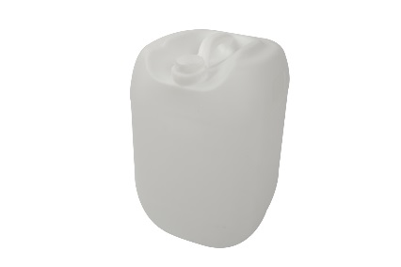 Liquid waste | Hazardous liquid waste  There are 6 waste streams in the basement for different types of liquid waste  1.Formaldehydes  2.Bouins  3.liquid DAB  4.Chlorinated waste  5.Non-chlorinated waste  6.Oils (not CCl4 waste) | White plastic bottles are used to dispose of smaller quantities of these liquids in the lab and then once full are taken down to the basement for disposal.  Lab support check these regularly. However, if full email CVS.lab.support@ed.ac.uk.  and use another located under CVS fume hoods
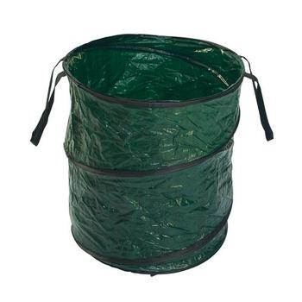  Recycling plastics | Plastics  Empty tip boxes cleaned and defaced chemical bottles | Wash-up will pick it up
Tip box by sink labelled Used batteries | Household used batteries. If you have large batteries from freezer alarms etc, please get in touch with lab management. | Will be disposed by Lab management

Waste Chemical Disposal
Check COSHH risk assessment for method of disposal. Small dilute quantities might be able to be disposed of to drains
1: Hazardous chemicals will be picked up by Chemistry
2: Large quantities of non-hazardous chemicals are also pick-up by Chemistry.

Hazardous Liquid Waste Disposal
FORMALDEHYDES e.g. formalin, formaldehyde and paraformaldehyde solutions
CHLORINATED WASTE (sometimes labelled PHENOL) e.g. Chloroform, Methacarn (chloroform, methanol, acetic acid mix), phenol and chloroform mixes, phenol waste oils (e.g. CCL₄ in olive oil)
NON-CHLORINATED WASTE (sometimes labelled ALCOHOL WASTE) e.g. acetone, ethanol, methanol, IMS, isopropanol, ether, non-halogenated waste, butan-1-ol, dimethylsulphoxide, Histoclear, xylene and xylene-alcohol mixes)

OTHER WASTE TO BE KEPT SEPARATE/ SPECIAL COLLECTIONS. ASK FOR EXTRA WASTE CONTAINERS.
Bouins e.g. formaldehyde, picric acid and acetic acid mix,
Liquid DAB (3.3 diaminobenzidine tetra hydrochloride),
Waste oils,
Beta mercaptoethanol,
Gluteraldehyde,
Borax (sodium tetraborate),
Sodium thiocyanate,
Formamide,
Picric acid (<3%).

WASTE BOTTLES CAN BE FOUND IN THE CABINETS UNDER THE FUMEHOODS.
ONCE FULL PLEASE TAKE DOWN TO THE FLAMMABLE STORE IN THE LOADING BAY, OR EMAIL LAB SUPPORT.

